🧠 SAP SYSTEM & ABAP BASICS – Your Gateway to Enterprise Logic
🚀 Introduction: Why ABAP Still Matters
In the age of web development and cloud computing, you might wonder — why learn ABAP?
Here’s a fact: over 70% of global business transactions touch an SAP system, and ABAP is the language that powers them.
SAP ABAP (Advanced Business Application Programming) is a high-level programming language created by SAP in the 1980s. It’s the core language used for building applications in the SAP ecosystem, particularly within the SAP ERP, SAP S/4HANA, and SAP NetWeaver platforms.
If you’re working on SAP implementations, migrations, or support, ABAP isn’t just useful — it’s essential.
🔧 1. Data Dictionary (DDIC): The Heart of ABAP
The Data Dictionary (SE11) is where all your database structures live. It defines tables, views, indexes, data types, Tables & more.
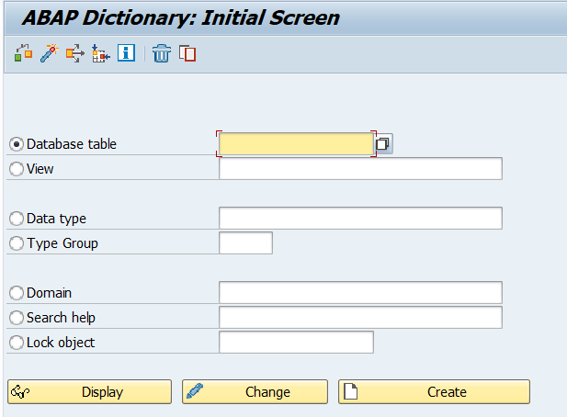
Key Components:
- Tables: Store actual data (Transparent, Pooled, Clustered)
- Domains & Data Elements: Control structure and data type behaviour
- Views: Logical joins on multiple tables
- Search Helps: Like dropdowns for input fields
💡Fact: ABAP tables don’t use primary keys the same way as typical SQL databases. Instead, the "key field" logic is enforced through the dictionary, making validations easier to maintain.
📊 2. ALV Reports: Beyond Boring Lists
ALV stands for ABAP List Viewer — SAP’s way of making reports beautiful, interactive, and useful.
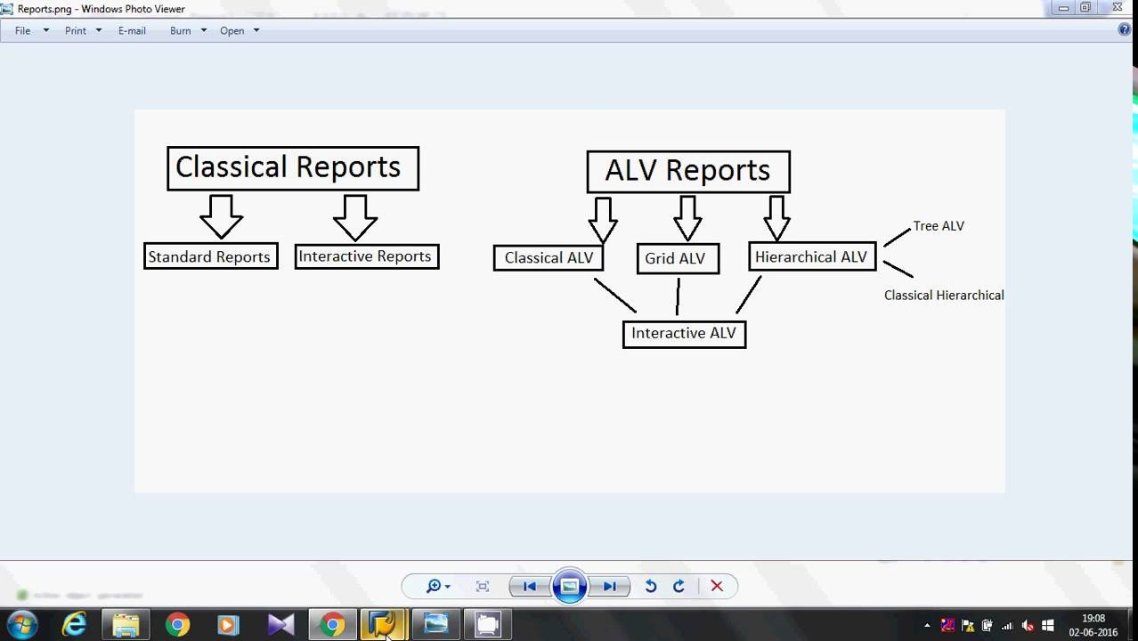
Types of ALV:
- Simple ALV – Straightforward list
- Interactive ALV – Clickable items
- Hierarchical ALV – Parent-child data (like invoice and items)
ALV automatically provides:
- Sorting
- Filtering
- Export to Excel
- Totals/Subtotals
🧩 Eg:- Used In: Vendor payment reports, purchase history summaries, customer aging reports.
💡 Did You Know? With just a few lines of code using REUSE_ALV_GRID_DISPLAY, you can turn a dull report into a user-friendly dashboard.
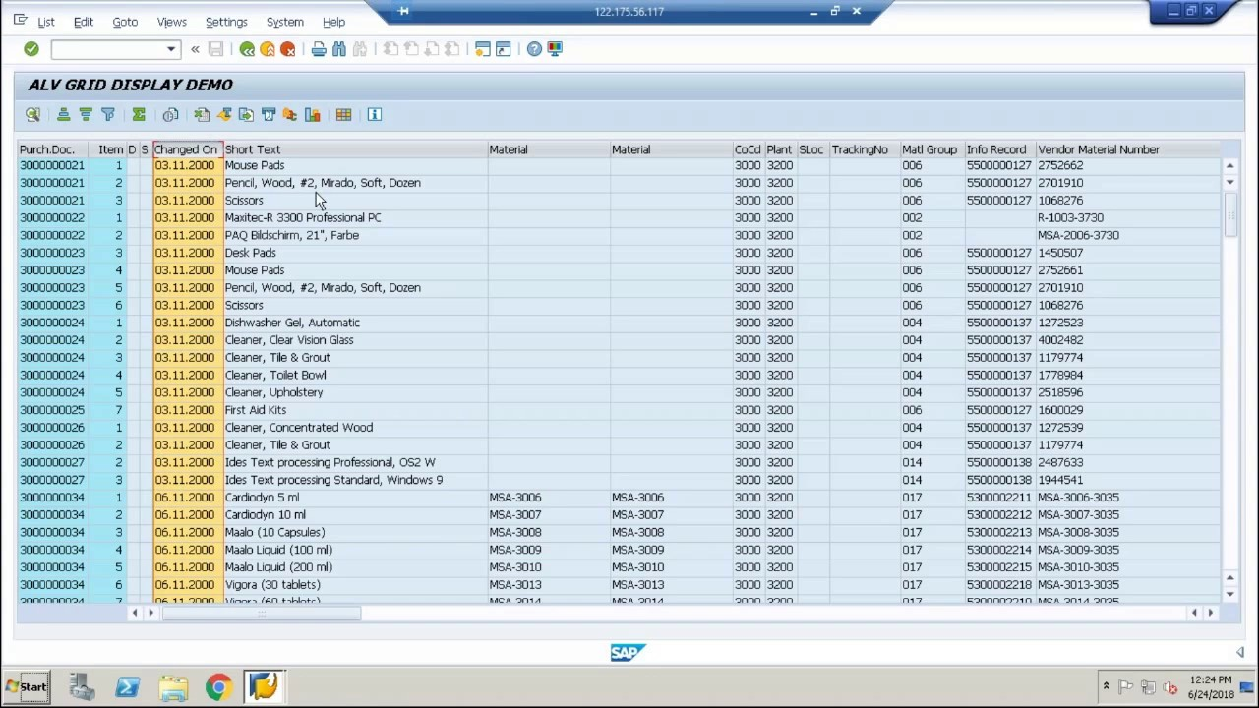
🔁 3. Function Modules: Reusability is Key
Function Modules are like helper tools — you can use them across programs.
Features:- Created using SE37
- Can handle exceptions and return tables
- Can be RFC-enabled for cross-system access
for rg:- You have a Java web application that needs to fetch employee salary details stored in SAP.
👇 Workflow:
- You create a Remote-Enabled Function Module (RFC FM) in SAP that returns employee salary data.
- SAP exposes this FM as an RFC endpoint.
- In your Java app, you use a connector like SAP JCo (Java Connector) to call that RFC.
- Data is transferred securely between systems.
📦 Popular Built-in FMs:
- DATE_GET_WEEK – Get week from date
- CONVERSION_EXIT_ALPHA_INPUT – Add leading zeros to customer numbers
💡 Fact: Some SAP modules internally call over 10,000+ function modules per day in large systems.
📝 4. SAP Scripts & SmartForms: Classic Print Solutions
Before Adobe came in, SAP Scripts and SmartForms were the go-to for printed documents.
SAP Scripts:
- Layout designed via SE71
- Multiple windows (MAIN, LOGO, etc.)
- Outdated but still used in legacy systems
SmartForms:
- Easier drag-and-drop UI
- XML-like structure
- Data flow separated from layout logic
🧾 Used In: Invoices, Delivery Notes, Pay Slips, Credit Memos
💡 Fact: SmartForms can call nested forms, letting you reuse subcomponents like footers or terms & conditions!

📄 5. Adobe Forms: The Modern Era
Interactive PDF forms with dynamic data? That’s where Adobe Lifecycle Designer comes in.
Adobe Forms are:
- Used with Web Dynpro, ECC, and S/4 HANA
- Great for dynamic and print-ready PDFs
- Offer Barcode, digital signature, and interactive fields
🧾 Real Use Case: Government tax forms or automated purchase order PDFs with input-enabled fields.
💡 Did You Know? Adobe Forms can embed JavaScript for field validations and calculations!

🔗 Putting it All Together: A Simple Business Flow
Business Requirement:
A client wants to print all purchase orders for vendors from the last 3 months, along with item-level details and digital signature.
ABAP Approach:
- Read purchase data using SELECT with inner joins (DDIC)
- Process the logic in a Function Module
- Display a preview via ALV Grid
- Generate printable Adobe Form with item table and vendor signature
💼 This type of end-to-end flow is what makes ABAP so powerful in enterprise applications.

📚 Conclusion: Mastering ABAP is Your SAP Superpower
ABAP is more than just syntax — it’s your tool to shape enterprise logic, improve user experiences, and ensure business processes run smoothly.
Whether you're just starting with ALV reports or venturing into Adobe Forms, mastering the ABAP basics opens doors to SAP's vast career paths: Developer, Consultant, Solution Architect, or even Tech Lead.
🔎 Pro Tip: Explore the transaction codes like SE11, SE37, SE38, SMARTFORMS, and SFP to practice what you just read.

You need to enter the T-CODES in Command field in SAP to navigate in the SYSTEM.
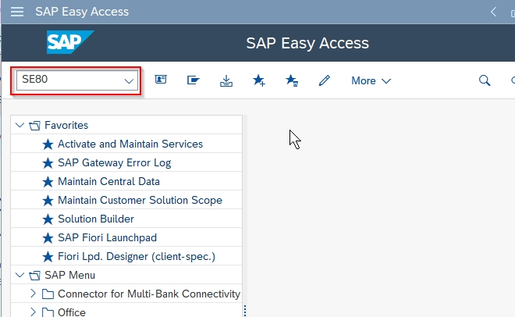
💡 Bonus: Handy T-Codes to Bookmark
Purpose | T-Code
Data Dictionary | SE11
Function Modules | SE37
Reports Editor | SE38
SAP Scripts | SE71
Smart Forms | SMARTFORMS
Adobe Forms | SFP
ALV Reuse FMs | SE93 (to find usage)
Object Navigator | SE80
Dump Analysis | ST22
Transport Organizer | SE09/SE10
Transport between clients | SCC1
Display objects in transports | SE95
Transport Management System | STMS (FOR TOC)

